COVERING SHEET – INSTRUCTIONS

THIS COVERING SHEET MUST BE REMOVED BEFORE SENDING EASY READ QUESTIONNAIRE TO SERVICE USER.

The availability of the Easy Read questionnaire will be signposted on the mailing letters and multi-language sheet, and administered at the request of the service user.
Once requested, the following steps should be taken.
Administering the request:
- Any highlighted yellow text on this Easy Read booklet should be personalised. The booklet contains both the Easy Read cover letter and questionnaire.
- The booklet should be posted to the service user alongside a return envelope. You can either use the Freepost address you have set up or include a stamped addressed envelope to a different processing address.
- Please log any Easy Read requests as ER_requested in the fieldwork monitoring spreadsheet.
- At the time of the service user requesting the Easy Read, if it is likely they will receive a further mailing (e.g. due to mailing deadlines) it is worth making them aware this will happen, but that an Easy Read will also be sent to them.
- If the service user does not take part in the survey, the code should be left as ER_requested in the separate column (which is excluded from the response rate), and an outcome code 6 added.

Processing the return:
- Manually enter responses into the excel data entry spreadsheet for Easy Read questionnaire responses.




Survey number: | [INSERT HERE]


Please tell us about the care you receive from NHS community mental health services
2023

 | Easy read version of the Community Mental Health Survey 2023
 |  | About this booklet
 |  | We would like you to answer some questions about the care you receive from community mental health services.
 |  | You might have seen someone from community mental health services in person, or on a video call or on the telephone.
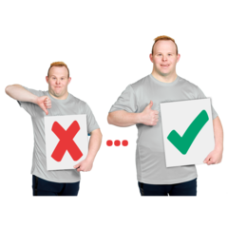 |  | Your answers will help improve community mental health services.
 |  | You can answer each question by putting a tick in the box next to the answer you want.
 |  | You can ask somebody to help you read the questions and answer them if you want.
 |  | But they should not tell you which answer to pick, because we want to know what you think.
 |  | You do not have to answer all the questions if you do not want to.
 |  | Your answers are private. We will not use your name when we share what we have found out from all the answers we receive.

 | Your care and treatment
 | - Thinking about the last year, how good were community mental health services at seeing you as often as you needed?
 |  | ☐ Very good
 |  | ☐ Good
 |  | ☐ OK
 |  | ☐ Bad
 |  | ☐ Very bad
 |  | ☐ I do not know or cannot remember
 |  | - Thinking about the last time you saw someone from community mental health services, how good were they at giving you enough time to talk?
 |  | ☐ Very good
 |  | ☐ Good
 |  | ☐ OK
 |  | ☐ Bad
 |  | ☐ Very bad
 |  | ☐ I do not know or cannot remember
 |  | - How good were the people you saw at organising your care and services?
 |  | ☐ Very good
 |  | ☐ Good
 |  | ☐ OK
 |  | ☐ Bad
 |  | ☐ Very bad
 |  | ☐ I do not know or cannot remember

 |  | - Thinking about the last time you saw someone from community mental health services, how good were they at involving you in decisions about your care and treatment?
 |  | ☐ Very good
 |  | ☐ Good
 |  | ☐ OK
 |  | ☐ Bad
 |  | ☐ Very bad
 |  | ☐ I do not know or cannot remember
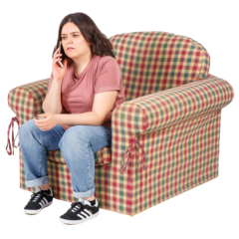    HELP! |  | - Thinking about the last time you needed help quickly because you were feeling worse. How good were people at community mental health services at helping you when you needed it?
 |  | ☐ Very good
 |  | ☐ Good
 |  | ☐ OK
 |  | ☐ Bad
 |  | ☐ Very bad
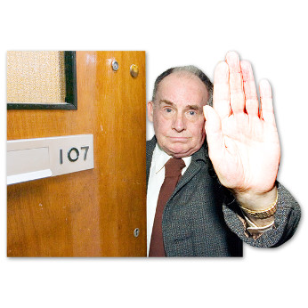 |  | ☐ I did not need this
 |  | ☐ I do not know or cannot remember
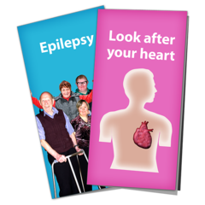 | - How good were the people you saw at supporting you with any physical health problems you might have?  A physical health problem might be an injury, disability, or condition like diabetes or epilepsy.
 |  | ☐ Very good
 |  | ☐ Good
 |  | ☐ OK
 |  | ☐ Bad
 |  | ☐ Very bad
 |  | ☐ I did not need this
 |  | ☐ I do not know or cannot remember

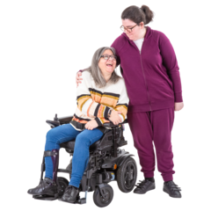 | - How good were the people you saw at including your family or someone else close to you in your care as much as you would like?
 | ☐ Very good
 | ☐ Good
 | ☐ OK
 | ☐ Bad
 | ☐ Very bad
 | ☐ I did not need this
 | ☐ I do not know or cannot remember
 | General questions
 | - In general, how good were the people you saw at treating you with respect?
 | ☐ Very good
 | ☐ Good
 | ☐ OK
 | ☐ Bad
 | ☐ Very bad
 | ☐ I do not know or cannot remember
 | - In general, how good was your experience of community mental health services?
 | ☐ Very good
 | ☐ Good
 | ☐ OK
 | ☐ Bad
 | ☐ Very bad
 | ☐ I do not know or cannot remember
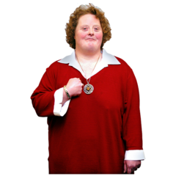 | About you
 | - How would you describe yourself?
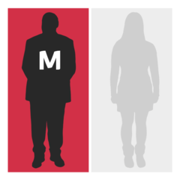 | ☐ Male
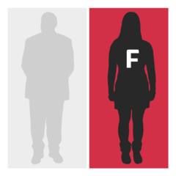 | ☐ Female
 | ☐ I do not want to say
 | ☐ Other (please write down how you would describe yourself below)
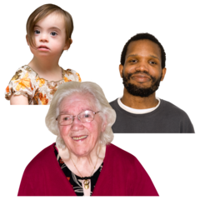 | - How old are you? Please write your age in years below.
 | Anything else
 | - Is there anything else you would like to tell us about your experience of using community mental health services? Please write it below.  We will take out any information that could identify you before making your answer public. But the NHS trust and the people (like CQC) you send these answers to will see your full answer. If your answer needs looking into, we may share it with the best person to help.
 | Thank you very much for answering these questions.
 | When we have looked at all the answers from everyone, we will write a report about what we found and put it on our website at: www.cqc.org.uk/surveys.
 | What to do with your answers
 | Please post your answers back in the FREEPOST envelope provided. No stamp is needed.
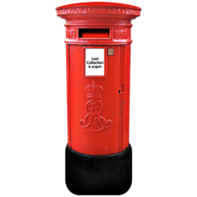 | If you do not have your FREEPOST envelope, please send your answers to <INSERT FREEPOST ADDRESS>

